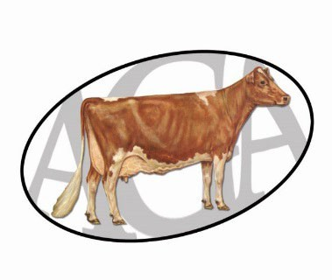
World Dairy Expo Substitute

Leadsperson Request Junior Guernsey Show

Name of owner(s): Cell Phone for Contact Person:
Age of owner: Class(es):

Reason that a substitute leadsperson is needed:

Name of substitute leadsperson: Age:

Cell phone of substitute leadsperson/parent:
RULES:
- Only ONE substitute leadsperson may be used per exhibitor, per show.

- A substitute leadsperson may only be used at ONE show per animal at any of the four National Junior Guernsey Shows each year.

- If the owner of the animal is present at the show, injury or multiple animals in the class are the only valid reasons for using a substitute.

- The substitute leadsperson must be the same age or younger than owner of animal(s). In the case of multiple owners, the substitute leadsperson must be younger than the oldest recorded owner.

- Leased animals MUST be shown by the lessee. Substitutes used on leased animals will disqualify the animal from the junior show. NO EXCEPTIONS.

Form must be turned into WDE Guernsey Superintendent or
AGA Executive Secretary by 5 p.m. on Saturday, September 27, 2025.
Approved:

Denied: Reason:

Official signature of AGA representative: Date and time turned in:

